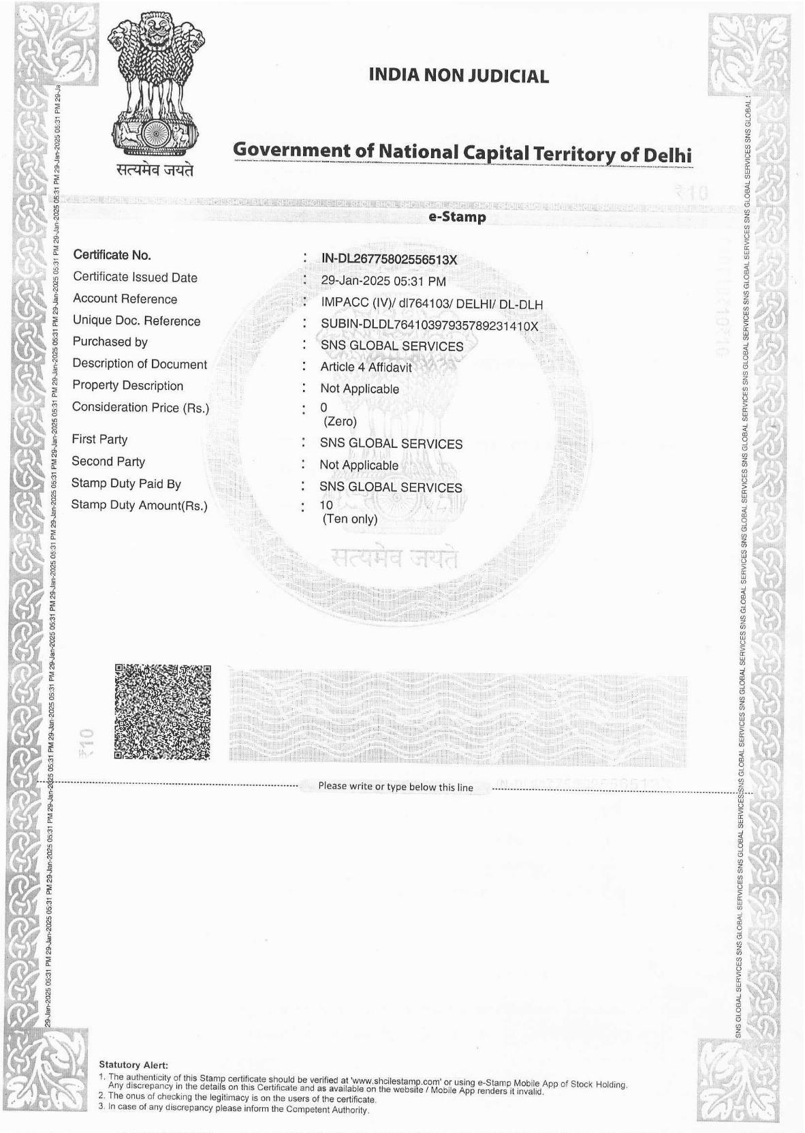





**AFFIDAVIT**

I, **Mr, MOHAMMAD SHAHABUDDIN MALLICK**  Managing partner **of SNS GLOBAL SERVICES** holder of the Registration Certificate No. **RA5195**  Mumbai.

, do hereby solemnly affirm and declare as under.

1. That the worker is being recruited for individual/personal requirement of the FE.
2. The requirement of the above worker has been conveyed by FE after obtaining the visa

Hence, the date of visa is prior to date of requirement/demand

1. That I RA is responsible of the genuineness of FE and authenticity of uploaded documents

Regarding FE registration.

1. That the worker will be deployed to the same foreign employer for whom he is recruited

and that he will be received by the Foreign Employer on reaching the country of

employment.

1. That the worker has been trade tested and found fit for the job for which he is being employed.
2. That the worker will be paid salary as per employment contract and shall be governed by standards of condition of employment as specific in the specimen employment contract.
3. That the worker will be deployed on the same job for which he is being recruited.
4. That I shall be responsible if the worker sent by me is found to be unfit in reaching the country of employment. The cost of repatriation in such case (s) will be borne by me.
5. That I am maintaining a register containing the above mentioned details of the worker.
6. That I/we have gone through the provision of sub-section (1) and (2) of section 37 of the emigration act/1983 and provision of section 193 of the Indian panel code 1860 [45 of

1860] relating to punishment for false evidence and have understood the contents

There of and undertake that in the event of any of the documents field along with or

referred to in this affidavit being found to be false, incorrect, fabricated tempered with

of changed I/We shall be liable under section 37 of the emigration act and section 193 of

Indian panel code.

1. That the intending emigrant has been apprised of the ground realities of the country of

the emigration. The problems he is likely to face such as those relating to lifestyle,

customs, religions practices, do’s and don’ts in the country of the emigration have been

informed to the intending emigrant.

1. I undertake to arrange thorough medical check-up of worker being deployed abroad

before he travels from India for the purpose.

1. That the worker has signed the employment contract which contents the seal and

Signature of the employer in my presence and that the same employment contract

counter signed by me with the seal of my agency and same has been handed over to him and receipt obtained.

1. This is to certify that the English translation of the documents in Arabic is the exact

Version of the original and I shall be responsible for its accuracy

1. Further it is to certify that I have conveyed the contents of the documents to the prospective emigrant in the local language understood by the emigrant/worker.
2. This is to certify that signature of the prospective emigrant in confirmation of this having heard/read and understood the contents of employment document has been obtained.
3. This is to certify that E-wakala submitted is genuine and relevant to submission. I/We undertake that in the event of any part or whole of it or the annexure being filed along with/referred to in this affidavit being found to be false, incorrect, fabricated tempered with or changed, I/We shall be liable to action under section 37 of the emigration act and

Section 193 of the Indian Panel Code.

1. This is to certify that in the employment agreement following conditions is included A) Free to and fro air-ticket, B) Free accommodation at the destination. C) Free food at the destination, D) Free transportation of mortal remains back to place of origin in India by

air in Case of death.

1. That my license is valid and not under suspension.
2. The foreign employer (s) is not under PAC (prior approval category)
3. That the emigrant is being recruited by our agency based on the interview/previous data

Of candidates/ Walk in interview/CV, selections of candidate have been found fit on trade test.

1. That the actual employment contract agreement submitted with the application of emigration clearance in genuine and duly signed by the concerned foreign employer and

the intending emigrant and that the same will be filed/submitted as per local laws to the concerned labour authorities in the country for enforcement purposes.

1. That I have uploaded the employment contract, in the approved format by the local government. It is duly signed by FE, emigrant and RA.
2. That the FE, is not registered at the emigrate portal.
3. That I have provided basic P-DOT to the emigrant on my own charge from the training

center, it is in the local language of the emigrants.

1. That I will never cross the limit of 10 workers recruitment of Ministry and the terms and conditions as per OM of 03rd August 2018 and 02nd June 2021 with the same FE.
2. That I have uploaded Demand Letter, Power of Attorney, Request Letter, Company ID

Card, Sponsor Photo ID Card, and with signature of the FE in optional attachment on

emigrate Portal.

1. That I have uploaded all genuine and correct documents viz. photo ID,signature etc.and

it is clearly visible preferably in colour copy.

1. That all the supporting document are genuine & legal and these are free from any tempering/forgery/Photoshop or IT enabled editing there has not been any tempering

with the FE ID/signature, emigrant’s signature etc.

1. That if a grievance is registered by the emigrant in the name of RA, I will take all possible steps to resolve the grievance as soon as possible up to the complete satisfaction of the emigrant.
2. This is further submitted that the company added by my office is a small in nature and located distantly for small works.
3. That the demand after the visa issue date is genuine and there is none of any mollified intention in contravening the provisions of FE rationalization policy laid down by MEA.
4. That, We will also issue the PBBY policy of the emigrant and will co-operate/help the emigrant/family if any claim is required in future.
5. That we will comply the PDOT training of emigrant as per instruction of your office
6. That there is no emigrant going to work as SEAMAN.
7. That we have not exceeded the limit of 10 worker as per ministry order dated 19/10/2022
8. That I have also explained the terms and conditions of his Employment contract to the emigrant in his mother tongue. A duly signed copy of this declaration, in the mother tongue of the emigrant is also enclosed herewith.

| **EMIGRANT NAME** |  |
| --- | --- |
| **PASSPORT NUMBER** |  |
| **NAME OF FOREIGN EMPLOYER** |  |
| **VISA NUMBER** |  |
| **VISA EXPIRY** |  |
| **FE ID** |  |
| **DESTINATION COUNTRY** |  |

1. That I have applied for emigration clearance as per the following details.
2. That I have followed the revised process for FE registration in accordance with OM dated 4th November, 2024 in this case.
3. That I have submitted correct FE details email ID and National ID of FE while registering the above said FE in the system.
4. In this case visa is issued before the date of demand for the reason that there were some technical reasons due to this the employer couldn’t raise the demand.
5. That I have arranged / not arranged P-DOT for the emigrant.
6. That I will not submit EC application for Seamen/ Seafarer/Fisherman or DSW (female).
7. That I will strictly adhere to Ministry’s order dated 09-07-2024 for Pre-orientation Departure training to the emigrant; and
8. That I will not submit EC application for the passports to which EC has been rejected by other POE’s.

Verification

Verified that the content of the above affidavit are true and correct to the best of my knowledge and belief and nothing has been concealed there from.

**DEPONENT**



**DECLARATION**

I,Shri MOHAMMAD SHAHABUDDIN MALLICK holder of the Registration Certificate No. B-6048/DEL**/**PER/300/234/5195/98 Proprietor issued by the Protector General of Emigrants, Ministry of External Affairs, Govt. of India, New Delhi, hereby declare as follows: -

1. That the emigrant **MOHAMMAD ARSHAD ALAM** with **M0742145** has been recruited by me and I have fully briefed him about his Employment contract i.e. Name of Foreign employer, job/occupation details for which he has been recruited, Country of Employment, period of contract, place of Employment, wages, allowances and other conditions of service.
2. That we have not charged them more than Rs 30,000/- Service charges prescribed by the office of PGE, New Delhi for his recruitment.
3. That I have also explained the terms and conditions of his Employment contract to the emigrant in his mother tongue. A duly signed copy of this declaration, in the mother tongue of the Emigrant is also enclosed herewith.

**घोषणा**

मैं, श्री मोहम्मद शहाबुद्दीन मल्लिक पंजीकरण प्रमाणपत्र संख्या दिल्ली B- B-6048/DEL/PER/300/234/5195/98केधारक**,** जो प्रवासियों के संरक्षक जनरल**,** विदेशमंत्रालय**,** भारत सरकार द्वारा जारी किए गए हैं।भारतसरकार, नईदिल्ली, के द्द्वारा नियमानुसार घोषित करता है: -

1. प्रवासी **MOHAMMAD ARSHAD ALAM** पासपोर्ट नंबर **M0742145** को मेरे द्वारा भर्ती किया गया हैऔर मैंने उन्हें उन के रोजगार अनुबंध यानी विदेशी नियोक्ताका नाम**,** नौकरी **/** व्यवसाय विवरण जिसके लिए उन्हें भर्ती किया गया है**,** रोजगार का देश**,** अनुबंध कीअवधिके बारे में पूरी तरह से जानकारी दी है। **,** रोजगार का स्थान**,** मजदूरी**,** भत्ते और सेवाकी अन्यशर्तें।
2. हमने उनसे उनकी भर्ती के लिए पी जी ई**,** नईदिल्ली के कार्यालय द्वारा निर्धारित30**,**000**/-**रुपये से अधिक सेवाशुल्क नहीं लिया है।
3. मैंने प्रवासी को उसके रोजगारअनुबंध के नियम और शर्तों को उसकी मातृभाषा में भी समझाया है।इस घोषणा की विधिवत हस्ताक्षरित प्रति**,** उत्प्रवासी की मातृभाषा में भी इस के साथ संलग्न है।



Signature of the Emigrant

( प्रवासीकेहस्ताक्षर) RA SIGNATURE